**Step 1:** You will be creating a web site for computer training institute. The website will have Home Page, Course Registration Page and a Success Page which will the confirm the user registration. Create a web page named Index.html. The Index.html page will give some information about the computer institute and the course being offered at the computer institute. The Index.html page should contain a link that redirects the user to the Course Registration page.

**Step 2:** Design a Course Registration Form as per the following specifications:

|  |  |  |
| --- | --- | --- |
| **Sr.No.** | **Form Field** | **Technical Specifications** |
| 1) | FirstName | Mandatory. Should be highlighted when form is loaded. Should display the text “Enter your first name”. This text should disappear once the user starts entering the FirstName. |
| 2) | LastName | Mandatory. Should display the text “Enter your last name”. This text should disappear once the user starts entering the FirstName. |
| 3) | Gender | Should display only two values: Male and Female. User should be able to select only one of these values. |
| 4) | Address | Can have multiple lines. |
| 5) | Age | Mandatory. Can contain only numbers between 18 to 50. |
| 6) | Country | User can choose only one country. |
| 7) | Date of Birth | Should only accept date. |
| 8) | Email | Mandatory. Should display the text “someone@gmail.com”. This text should disappear once the user starts entering the email address. Email address should be in proper format. |
| 9) | PhoneNo | Mandatory. Should be in {ddd}-{ddd}-{dddd} format. Should display the text “123-456-7890”. This text should disappear once user starts entering the PhoneNo. |
| 10) | UserName | Mandatory. |
| 11) | Password | Mandatory. Can contain maximum 20 characters. |
| 12) | Course | User can choose one or more of the following courses:  .NET Core, Azure Developer and Agular 10. |
| 13) | Total Experience | Should be between 1 to 10. Default should be 5. User should be able to increase or decrease the experience using the slider. |
| 14) | Resume | User should be able to upload the resume. |
| 15) | Favourite Colour | User should be able to choose favourite colour using colour pallet. |
| 16 |  | Form should have Save and Cancel buttons. On clicking the Save button, user should be redirected to a page named “Success.html”. The “Success.html” page should display the message “Congratulations!!! You have registered successfully.” On Clicking the Cancel button, all form fields should display their default values. |

Course Registration Form should look as follows:

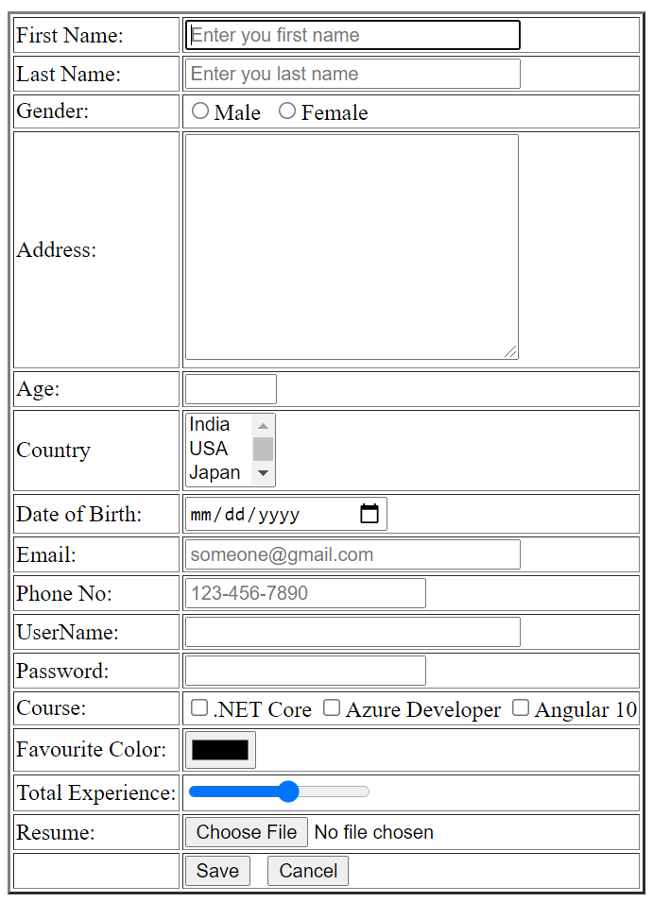

**Step 3:** Change the look and feel of Course Registration, Index.html and Success.html pages.

i) Course Registration Form should have some background colour.

ii) Save button should have a Blue colour. Text Save should be displayed in White color.

Cancel button should have a Grey color. Text Cancel should be displayed in White color.

The code to specify the look and feel of these web pages should be specified in a separate file.

The sample look and feel for Course Registration form is shown below:

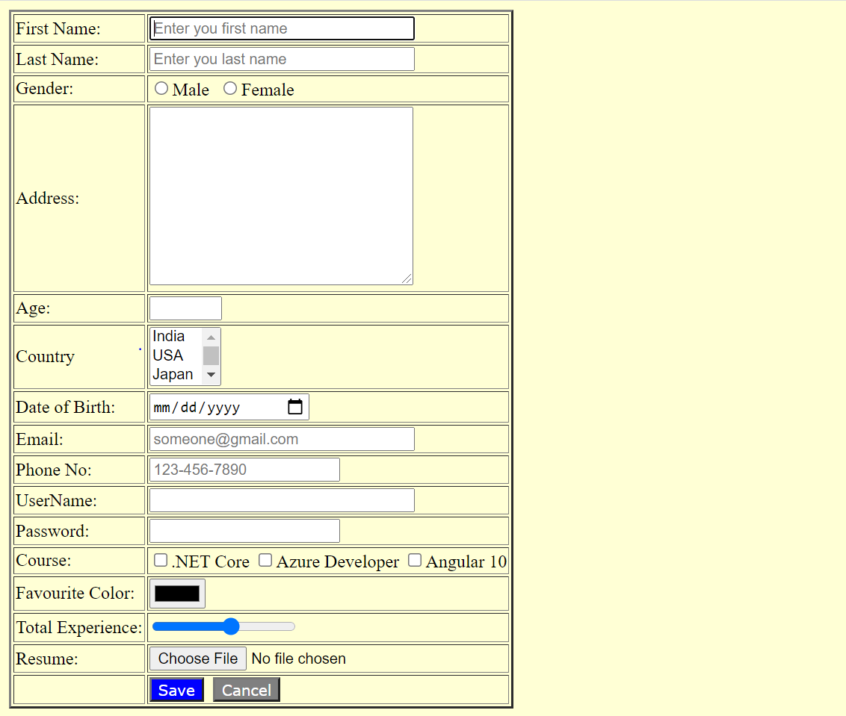

Also apply some styles to Index.html and Success.html pages.

**Step 4:** You need to make sure the user has selected at least one course. If the user has not selected any course, the error message “Please select at least one course” should be displayed. Write a code to fulfill this requirement.